****Project Objective:****

As a developer, write a program to find the longest increasing subsequence.

****Background of the problem statement:****

As a developer, write a Java code to find the longest increasing subsequence from a list of random numbers.

**Source Code :-**

**import** java.util.Scanner;

**public** **class** LongestIncreasingSubsequence

{

**public** **int**[] lis(**int**[] X)

{

**int** n = X.length - 1;

**int**[] M = **new** **int**[n + 1];

**int**[] P = **new** **int**[n + 1];

**int** L = 0;

**for** (**int** i = 1; i < n + 1; i++)

{

**int** j = 0;

**for** (**int** pos = L ; pos >= 1; pos--)

{

**if** (X[M[pos]] < X[i])

{

j = pos;

**break**;

}

}

P[i] = M[j];

**if** (j == L || X[i] < X[M[j + 1]])

{

M[j + 1] = i;

L = Math.*max*(L,j + 1);

}

}

**int**[] result = **new** **int**[L];

**int** pos = M[L];

**for** (**int** i = L - 1; i >= 0; i--)

{

result[i] = X[pos];

pos = P[pos];

}

**return** result;

}

**public** **static** **void** main(String[] args)

{

**try** (Scanner scan = **new** Scanner(System.***in***)) {

System.***out***.println("Enter number of elements");

**int** n = scan.nextInt();

**int**[] arr = **new** **int**[n + 1];

System.***out***.println("\nEnter "+ n +" elements");

**for** (**int** i = 1; i <= n; i++)

arr[i] = scan.nextInt();

LongestIncreasingSubsequence obj=**new** LongestIncreasingSubsequence();

**int**[] result = obj.lis(arr);

System.***out***.print("\nLongest Increasing Subsequence : ");

**for** (**int** i = 0; i < result.length; i++)

System.***out***.print(result[i] +" ");

}

System.***out***.println();

}

}

**Outout :-**

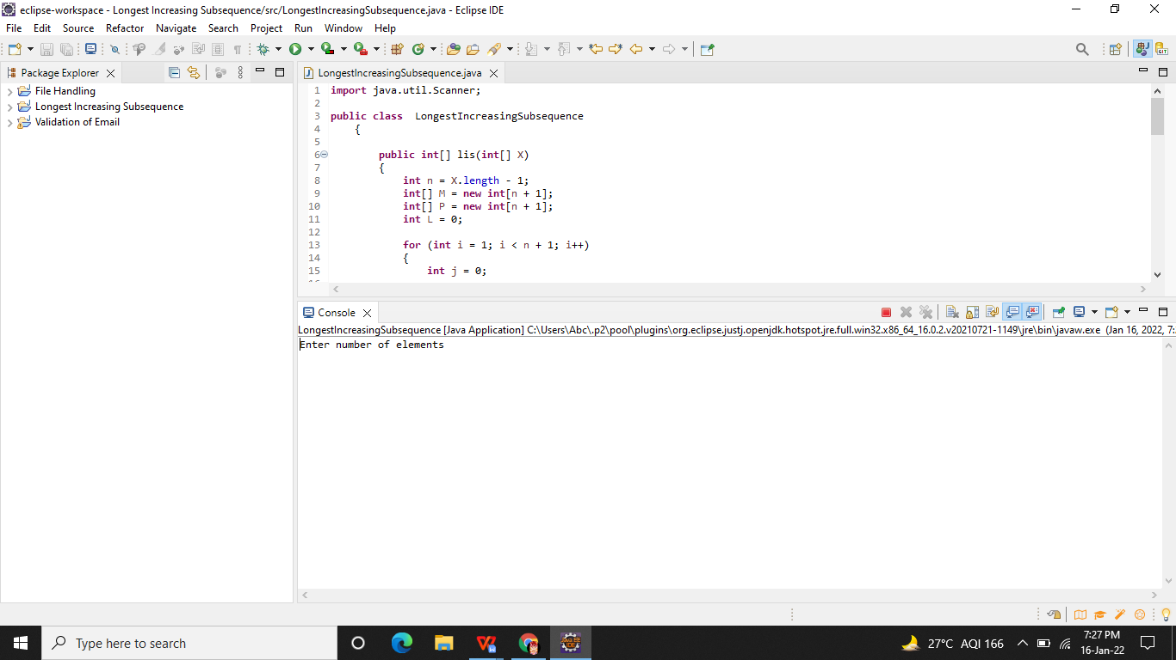

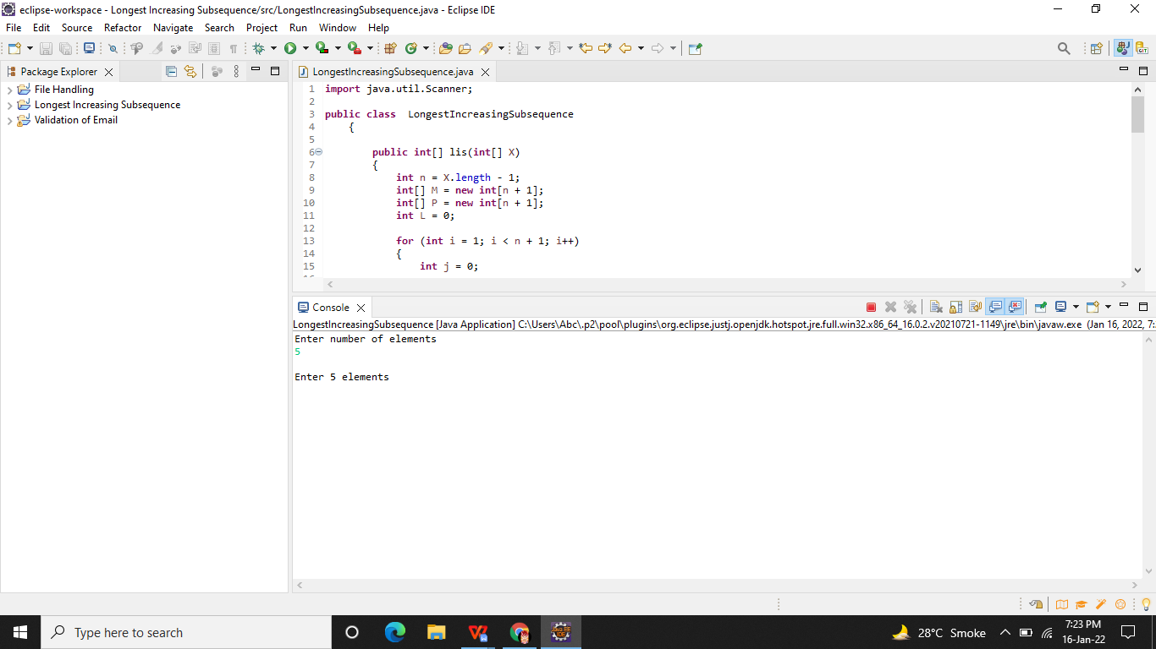

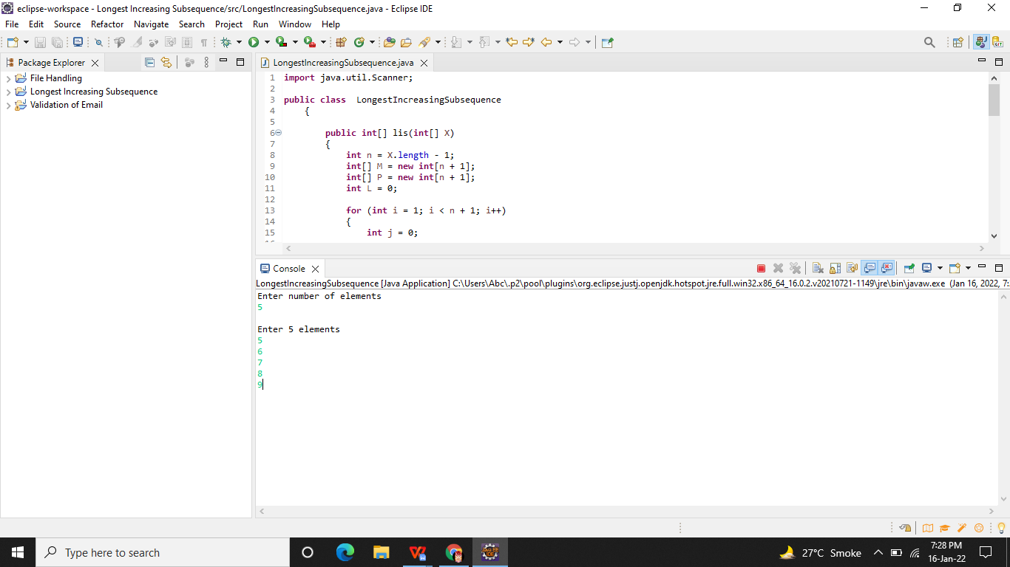

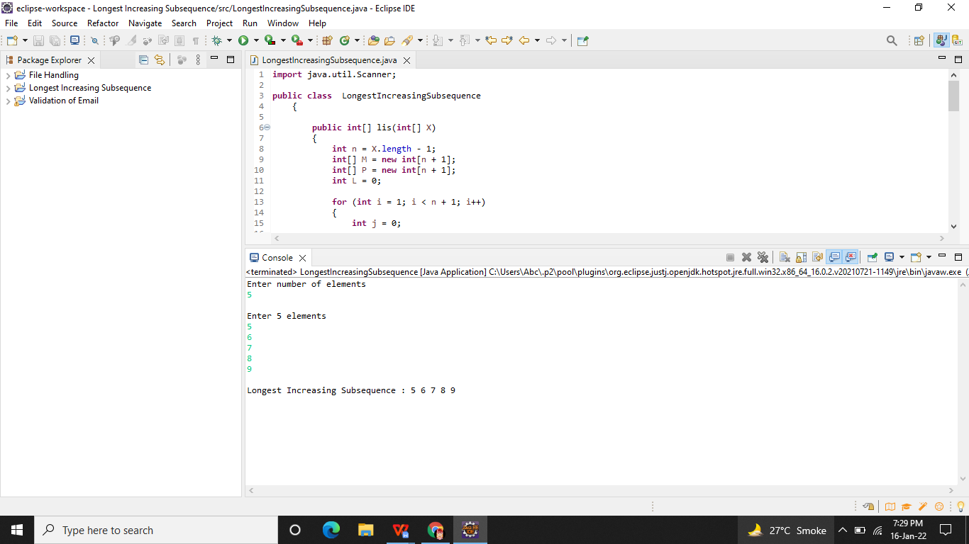

**Github Link -**

**https://github.com/Aniket03-op/Project.git**